**Abstract**

We investigate the photon-mediated magnon-magnon coupling between spatially separated Yttrium-Iron-Garnet (YIG) and Permalloy thin films integrated on a hexagonal ring resonator (HRR). Using theoretical modeling and CST Studio simulations, we demonstrate measurable magnonmagnon coupling despite having neglected direct dipolar interaction. Our observations reveal a dependence of the unvaried Permalloy film’s coupling strength on the YIG film’s coupling strength, indirectly relating both by one’s thickness. The model accurately predicts transmission spectra (*S*21) for varying parameters while highlighting an interdependence of coupling strengths between the two films not directly implied. These findings underscore the significance of photon-mediated interactions in designing scalable magnonic circuits and provide insights into crosstalk mechanisms in hybrid quantum systems while maintaining a low-cost experimental set-up to maximize accessibility. Our work furthers the understanding of unintended interactions and crosstalk within hybrid quantum systems applied to quantum information processing.

Coupling induction-depression by a decoupled magnon

Fizaan Khan *et al.*

April 19, 2025

# Introduction

The development of hybrid quantum systems that integrate magnonic and photonic components has emerged as a critical frontier in quantum information science and microwave technologies[1, 2]. As device architectures shrink toward nanoscale dimensions[3, 4], unintended interactions between spatially separated circuit elements mediated by shared electromagnetic environments pose challenges and opportunities for engineering coherent information transfer[5, 6].

Due to their exceptional spin-wave coherence properties, modern quantum architectures increasingly rely on Yttrium-Iron-Garnet (YIG) ferrimagnet films and related low-damping materials to implement magnonic circuits[1, 2, 7, 8]. These systems exploit strong magnon-photon coupling in superconducting resonators to achieve energy transfer between spin ensembles and microwave photons. Recent breakthroughs demonstrate ultrastrong coupling regimes (couplingto-frequency ratios *>* 0.2) in YIG-coplanar waveguide hybrids[8]. Concurrently, lithographically patterned organic ferrimagnets show cooperativities exceeding 103 at cryogenic temperatures, highlighting the potential for scalable integration with superconducting qubits[5].

While the Dicke model adequately describes single magnon-photon coupling, it fails to capture multimode interactions in heterogeneous magnetic systems[9, 10]. Key unresolved challenges include mediated coupling dynamics, spin density dependencies, and decoherence pathways.

It is, therefore, prudent to add to the literature on indirect interactions. Hyde et al. observed that certain indirectly coupled modes can exhibit higher microwave transmission than their individually uncoupled counterparts [11]. This raises the question of just how far from the tree the apple falls. As the cavity photon was asserted to be a good mediator for long-distance indirect coupling of hybrid systems[12], we chose a hexagonal ring resonator (HRR) to do the honors.

This study demonstrates that photon-mediated interactions between a YIG film spatially separated from a Permalloy film (NiFe) over the ring resonator produce measurable magnon-magnon coupling despite negligible direct dipolar overlap. Our findings reveal that the interaction strength depends on the nonlocal effects of circuit elements, which are initially assumed to be disparate. This effect persists even when the individual magnon-photon couplings remain below the ultrastrong regime threshold, suggesting that mediated interactions

2

require a re-evaluation of crosstalk mitigation strategies in magnonic integrated circuits.

As an alternative to the Schrieffer-Wolff transformation[13, 14], we use the input-output theory[15, 16] to obtain the *S*21 parameter. Further, our technique aims to be accessible: designed on the millimeter scale with resource limitations in mind, observations are made at room temperature and signify analogous phenomena in cQED. This leads to low-cost fabrication and setup of the overall design.

# Motivation

In developing hybrid systems of any type, one must appreciate the various hybridizations and their overall effect on system dynamics. To do this, we consider the effects of magnonic interactions in a configuration expected to have minimal direct overlap, while indirectly being mediated by another boson. In Fig 1, we observe the interaction of either one or two magnons interacting with a resonator photon driven by an AC field.

The resonant frequency of the photon is a constant dependent on its dimensions since we model it here with an LC oscillator, and therefore, it must be a constant frequency. The magnons follow Kittel’s formula[17], a power law function. The strength of the coupling is directly related to the extent of avoidedness of their crossing, a good measure of their utility in quantum sensing arrays or memory buses.

While the Permalloy [BECAUSE OF BEING A FERRIMAGNETIC IN-

SULATOR?] introduces a fair amount of noise, it is clear that its coupling to the resonator photon is not strong in isolation. The YIG magnon has greater coupling strength with the photon.

This work was inspired by the observation of Fig 1(c). One can see here that the coupling strength of the Permalloy is suddenly larger and better visible, while the YIG coupling has probably even decreased.

# The Model

The theory we propose in this work is a generalized version that may be extended to any number of quantum harmonic oscillators. We are specifically interested in a triple oscillator system: a cavity photon coupled to two thin magnonic films. A driving field is provided through a microstrip line (denoted in equation (3) as “msl”), which is assigned the annihilation (creation) operator

). The subscript *k* denotes a frequency-dependent operator that supports all frequencies, implying an integral over all real *k*.

For each of the oscillators, we define yet again the annihilation (creation) operator as ˆ*bj* (ˆ*b*†*j*), where *j* takes on one of the symbols *r* (denoting the photonic resonator), 1 or 2 (denoting the magnonic resonators).

We begin with the definition of the system’s Hamiltonian *H*ˆ = *H*ˆnon-int + *H*ˆint+*H*ˆmsl, denoting the non-interacting, interacting, and microstrip line hamiltonians respectively, where each expands to

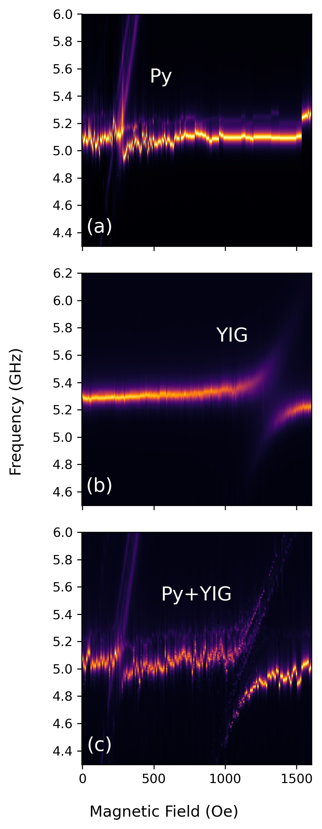

Fig 1: A comparison of the magnonic coupling strengths of the (a) Permalloy, (b) YIG, and (c) both in an indirectly coupled configuration.

*H*ˆnon-int*/*¯*h* = X *ω*˜*j*ˆ*b*†*j*ˆ*bj* (1)

*j*∈{*r,*1*,*2}

 + h.c. (2)

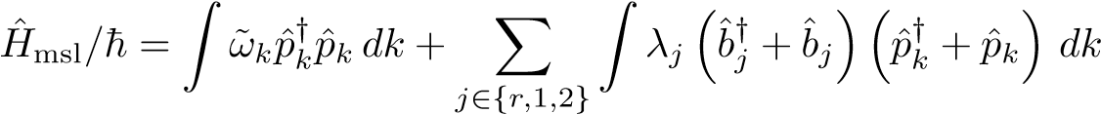 (3)

The quantity ˜*ωj* = *ωj* + *iαj* refers to the natural frequency of the oscillator and includes its intrinsic damping constant *αj*.

The microstrip line requires a continuous integral over all supported input frequencies. Equation (3) represents the driving field Hamiltonian of the microstrip line. In contrast, equation (2) includes the coupling of all the resonators amongst themselves and a term that captures the coupling of each of the resonators with the microstrip line.

Note a term of direct dipolar coupling between ˆ*b*1 and ˆ*b*2: *g*3. As shall be seen, however, its contribution to the *S*21 parameter is negligible.

The equations of motion for the three oscillators are readily calculated by a standard procedure[18, 16].

If we set *γi* = 2*πλ*2*i*, the *S*21 parameter for such a system, given by *S*21 =

*p*ˆout*/p*ˆin − 1 is[19]

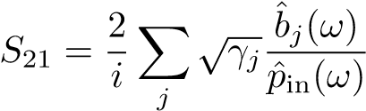 (4)

which, rewritten in the form of a matrix

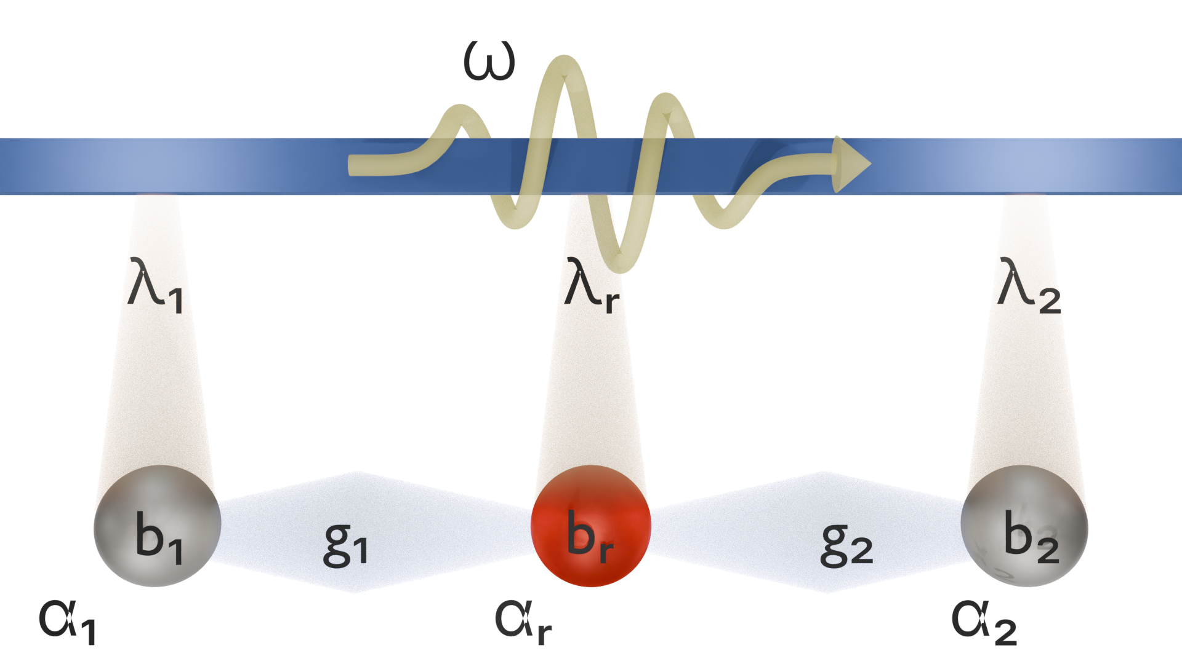

Fig 2: A cartoon of the model developed for this system. The spheres are bosonic oscillators with creation (annihilation) operator ˆ*b*†*j*(ˆ*bj*). *αj* and *λj* denote intrinsic and extrinsic damping, coupling the oscillators to the traveling photon mode. The constants *g*1 and *g*2 denote the coupling of the magnonic cavities to the photonic cavity.

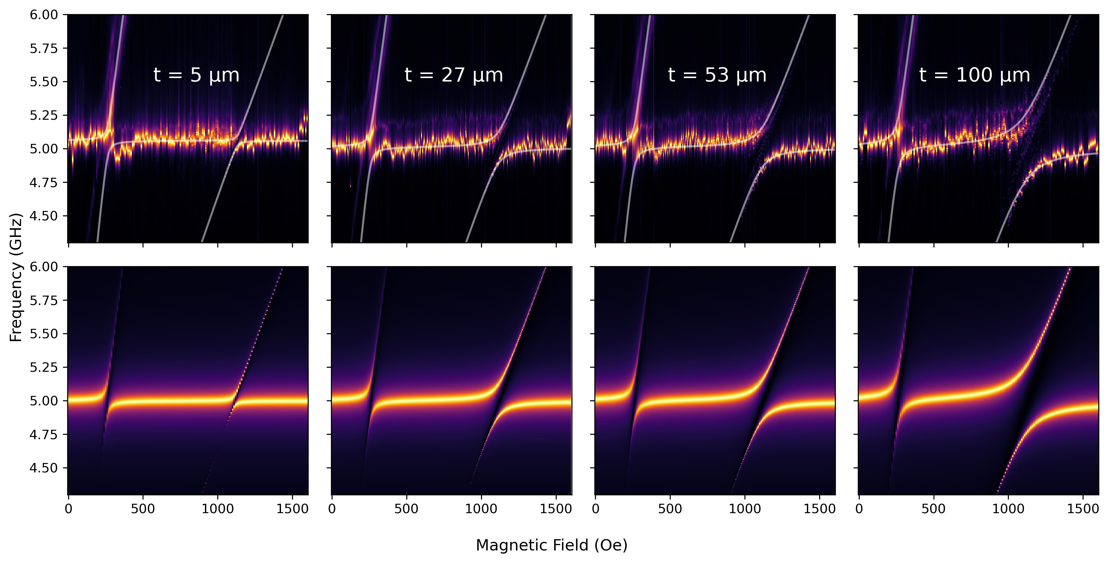

Fig 3: Observed (top row) and calculated (bottom row) *S*21 spectra of the system for corresponding thicknesses of YIG. The Permalloy crossing is also seen to widen with a change in YIG thickness.

*S*21 = *BT*M−1*B* (5)

where

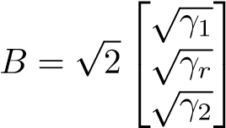 *,*

and , where *I* is the 3×3 identity matrix and *H*ˆcoupling is the effective coupling Hamiltonian[19], from the equations of motion for the mode operators, given by

*H*ˆcoupling 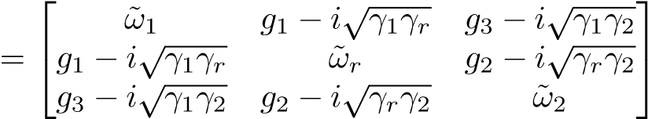 (6)

The terms on the diagonal include intrinsic and extrinsic damping terms, in the form ˜*ωj* = *ωj* − *i*(*αj* + *γj*)[19], and *ωj* represents natural frequency of oscillator *j*. Since we are ignoring terms of direct magnon coupling, there are no coupling constants on the edges of the off-diagonal.

# Three-Mode Results

The measurable quantity is the coupling strength among resonators; at the coupling centers, this denotes the extent to which the crossing of the peaks in the *S*21 spectrum is avoided and may be measured by corresponding peak separation. The coupling is a result of classical phenomena[12].

Past analyses have shown that it depends broadly on intrinsic material parameters such as *αj*[20]. While the model predicts related effects for large *αj*, they occur in discrete steps, in contrast with what we have (thus far) observed.

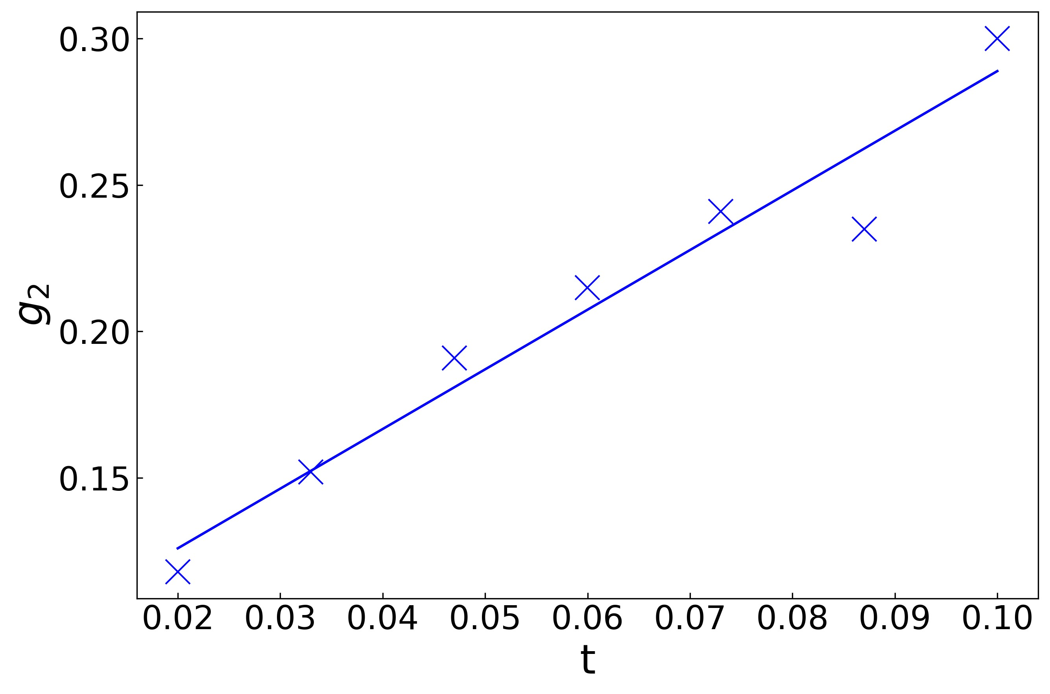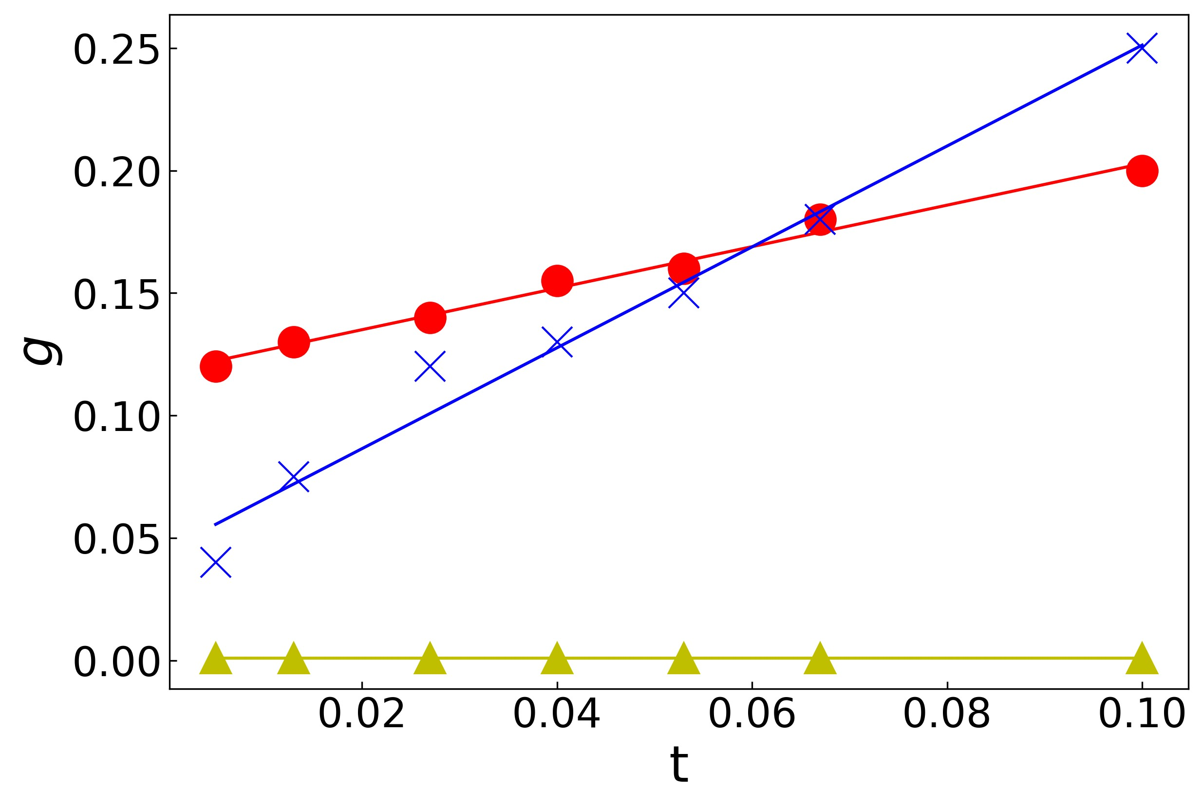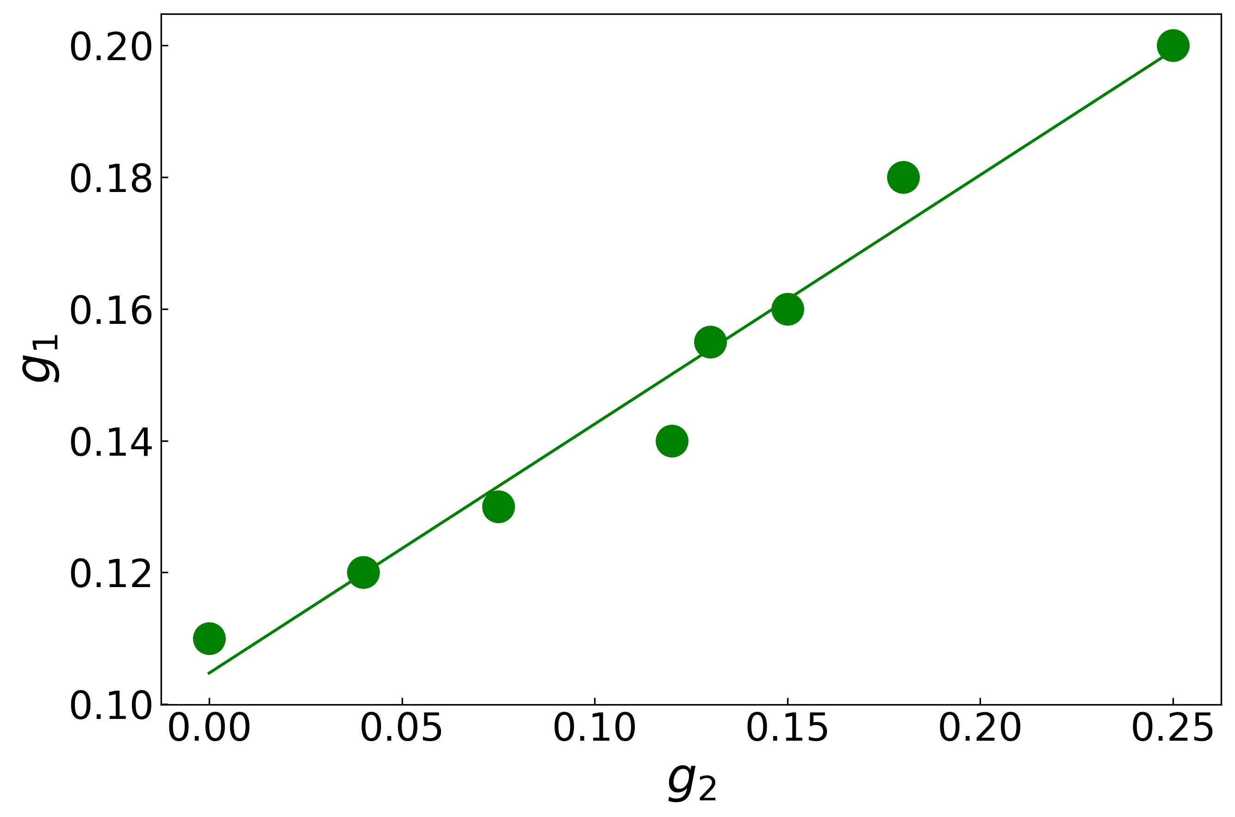

(a) (b) (c)

Fig 4: The blue crosses in (a) and (b) represent the coupling strengths of the YIG film to the HRR. The coupling strengths in (a) are for a system that does not include a Permalloy film. Upon introduction of the Permalloy in (b), the coupling strengths of the YIG have decreased by a fixed amount. The red dots in (b) mark the coupling strengths of the Permalloy to the HRR, and the yellow triangles are *g*3, the direct coupling between YIG and Permalloy, which is small due to the low overlap configuration. In (c), we plot the relation *g*1(*g*2), which is also linear.

Seen in Fig 3 are the *S*21 spectra observed (top) and predicted by the theory (bottom), respectively, for various thicknesses of the YIG ferrimagnet. The details of the setup are discussed in detail in section 5. The parameters *g*1, *g*2 and *g*3 were fitted such that the overlay of the white curves (the peak positions are the eigenvalues of the coupling Hamiltonian (6) at each magnetic field strength *H*) on the observation was the closest possible, and then the full spectrum was plotted separately. This best fits the relevant model parameters, which agree well with observations.

Going from left to right in Fig 3, the thickness of the YIG film is increasing. Predictably, the coupling of this magnon with the HRR increases with this thickness. Interestingly, we note that the Permalloy film’s coupling with the resonator also depends on the thickness of the other film.

When the coupling strength of the YIG film in the absence of Permalloy is plotted against its thickness (Fig 4a), it follows a linear trend. On the introduction of the Permalloy film (Fig 4b), the slope remains the same (at about 2), but the line shifts downward. The Permalloy seems to return an unchanging influence on the coupling strength of the YIG mode. Note, however, that *g*3 is negligibly small due to our selection of a low overlap configuration. Any observable interaction between the two magnons in this configuration is mediated through the resonator photon.

This sensitivity to an external parameter of the Permalloy film seems to suggest an indirect dependence on the YIG film that is not captured within the scope of the quantum model. There is perhaps a transfer of energy or an overlap of the magnetic fields.

It seems to us most appropriate at this point to claim that the quantity *g*1 depends on *g*2 linearly, as is seen in Fig 4c. It inspires confidence to see that *g*1(0) is non-zero and, in fact, the coupling constant of the Permalloy film in the absence of YIG.

# Experimental setup

We built a system within CST Studio, shown in Fig 5, to simulate an experimental setup. Between ports 1 and 2 is the transmission (or microstrip) line, which is capacitively coupled to the HRR.

The dielectric substrate is made of Rogers RO3010 laminate (which has a dielectric constant of 10.2) and coated with a copper layer on one side as the ground plane. The thin films are made of Yttrium-Iron-Garnet (YIG, white square in Fig 5) and Permalloy (Py, green square). The thin films have been placed on the resonator at opposing positions, Permalloy on the segment of the hexagon closest to the microstrip line, and Yttrium-Iron-Garnet on the furthest segment. We chose this configuration because Verma *et al.*[21] reported that in this configuration, the thin films see the greatest coupling of all the positions they tested.

The physical dimensions chosen for the substrate, transmission line, and thin films are in table 1, while intrinsic material properties are given in table 2.

A magnetic field is applied across the substrate and swept from 0 to 1.6 kOe along the *y*-direction. This range is selected so that the resonant frequency of the ring resonator (which depends only on its geometry) would intersect the resonant frequencies of the thin films within this regime, effectively exciting the magnons. The field driven through the transmission line excites the photonic cavity mode, whose resonant frequency depends only on its own physical dimensions.

|  |  |
| --- | --- |
| Parameter | Value (mm) |
| Thin film side length (Py & YIG) | 3 |
| Py thickness | 0.02 |
| HRR outer radius | 4 |
| HRR inner radius | 3.4 |
| MSL width | 0.57 |
| Substrate length | 30 |
| Substrate width | 20 |
| Substrate thickness | 0.64 |
| Copper thickness (MSL and ground plane) | 0.035 |

Table 1: Dimensions of the sample

|  |  |
| --- | --- |
| Parameter | Value |
| YIG Sat. Mag. (4*πM*) | 1750 G |
| YIG Gyromag. Ratio (*γ*) | 1*.*76 × 10−2*/*2*π* |
| Py Sat. Mag. (4*πM*) | 10900 G |
| Py Gyromag. Ratio (*γ*) | 2*.*94 × 10−3 |

Table 2: Material properties

# Remarks

## Implications

Foreseeably, these findings are relevant to general hybrid quantum systems, including those in the nanoscale regime. A classical or quantum effect influences seemingly unrelated quantities to be affected by each other, which must be taken into account when designing such systems for quantum information processing or quantum sensing.

Just like any tool, this too must be seen not only for its cons but also its pros. For example, in microwave photonics, this degree of freedom may complement phase-control capabilities demonstrated in traveling-wave-mediated systems[22, 23]. Long-range magnon entanglement via cavity photons could enable distributed magnetometry arrays, building on the strong cooperativities (*C* ∼ 103) achieved in lithographed organic ferrimagnets. Mediated interactions may also facilitate error-protected state storage through multimode interference, though this requires suppressing induced dephasing as observed in ultrastrong coupling regimes.

## Accessibility

By leveraging room-temperature operation and millimeter-scale components, our approach circumvents the need for cryogenic infrastructure or nanofabrication, making a step towards accessible magnonic cavity designs. The experimental framework’s compatibility with standard PCB fabrication techniques and macroscopic dimensions (3 mm films, 4 mm resonator radius) significantly lowers the barrier for low-funded laboratories to explore quantum magnonics. This aligns with recent demonstrations of room-temperature meterscale magnon-photon coupling in coaxial systems[23], proving that observable interactions need not rely on submicron lithography or millikelvin environments.

## Limitations

While our quantum model successfully reproduces the anti-crossing features in transmission spectra, it fails to predict the exact functional dependence of *g*1(*g*2)—the Permalloy coupling’s nonlinear response to YIG thickness variations. This discrepancy suggests unaccounted higher-order processes, possibly involving hybridized magnetostatic surface spin waves (MSSWs) as observed in confined YIG cavities[24]. Furthermore, the omission of thermal bath interactions leaves questions about phonon-mediated decoherence, which is particularly relevant given recent findings in epsilon-near-zero magnonic systems where thermal fluctuations drastically modify coupling spectra.

## Concluding Remarks

In conclusion, this work bridges the gap between fundamental magnonics and practical device engineering. Elucidating photon-mediated coupling in accessible macroscopic systems provides a roadmap for low-cost classical applications and future quantum technologies requiring precise control over indirect spinphoton interactions. The results underscore the necessity of revisiting cQED models to account for all co-dependent phenomena.

# References

1. Biswanath Bhoi, Bosung Kim, Junhoe Kim, Young-Jun Cho, and SangKoog Kim. Robust magnon-photon coupling in a planar-geometry hybrid of inverted split-ring resonator and yig film. *Scientific Reports*, 7(1):11930, Sep 2017.
2. Dinesh Wagle, Anish Rai, Mojtaba T Kaffash, and M Benjamin Jungfleisch. Controlling magnon-photon coupling in a planar geometry. *Journal of Physics: Materials*, 7(2):025005, February 2024.
3. Justin T. Hou and Luqiao Liu. Strong coupling between microwave photons and nanomagnet magnons. *Phys. Rev. Lett.*, 123:107702, Sep 2019.
4. Yi Li, Tomas Polakovic, Yong-Lei Wang, Jing Xu, Sergi Lendinez, Zhizhi Zhang, Junjia Ding, Trupti Khaire, Hilal Saglam, Ralu Divan, John Pearson, Wai-Kwong Kwok, Zhili Xiao, Valentine Novosad, Axel Hoffmann, and Wei Zhang. Strong coupling between magnons and microwave photons in on-chip ferromagnet-superconductor thin-film devices. *Phys. Rev. Lett.*, 123:107701, Sep 2019.
5. Qin Xu, Hil Fung Harry Cheung, Donley S. Cormode, Tharnier O. Puel,

Srishti Pal, Huma Yusuf, Michael Chilcote, Michael E. Flatt´e, Ezekiel Johnston-Halperin, and Gregory D. Fuchs. Strong photon-magnon coupling using a lithographically defined organic ferrimagnet. *Advanced Science*, 11(14):2310032, 2024.

1. Haechan Jeon, Bojong Kim, Junyoung Kim, Biswanath Bhoi, and SangKoog Kim. Anomalous coherent and dissipative coupling in dual photonmagnon hybrid resonators. *Scientific Reports*, 14(1):13581, Jun 2024.
2. Paolo Andrich, Charles F. de las Casas, Xiaoying Liu, Hope L. Bretscher, Jonson R. Berman, F. Joseph Heremans, Paul F. Nealey, and David D. Awschalom. Long-range spin wave mediated control of defect qubits in nanodiamonds. *npj Quantum Information*, 3(1), July 2017.
3. Alberto Ghirri, Claudio Bonizzoni, Maksut Maksutoglu, Alberto Mercurio, Omar Di Stefano, Salvatore Savasta, and Marco Affronte. Ultrastrong magnon-photon coupling achieved by magnetic films in contact with superconducting resonators. *Phys. Rev. Appl.*, 20:024039, Aug 2023.
4. I.A. Golovchanskiy, N.N. Abramov, V.S. Stolyarov, A.A. Golubov, M. Yu. Kupriyanov, V.V. Ryazanov, and A.V. Ustinov. Approaching deep-strong on-chip photon-to-magnon coupling. *Physical Review Applied*, 16(3), September 2021.
5. R. D. McKenzie, M. Libersky, D. M. Silevitch, and T. F. Rosenbaum. Theory of magnon polaritons in quantum ising materials. *Phys. Rev. A*, 106:043716, Oct 2022.
6. Paul Hyde, Lihui Bai, Michael Harder, Christophe Match, and Can-Ming Hu. Indirect coupling between two cavity modes via ferromagnetic resonance. *Applied Physics Letters*, 109(15):152405, 10 2016.
7. Vahram L. Grigoryan and Ke Xia. Cavity-mediated dissipative spin-spin coupling. *Phys. Rev. B*, 100:014415, Jul 2019.
8. Vahram Grigoryan and Jiang Xiao. Dynamical spin-spin coupling of quantum dots. *Europhysics Letters*, 104(1):17008, oct 2013.
9. J. R. Schrieffer and P. A. Wolff. Relation between the anderson and kondo hamiltonians. *Phys. Rev.*, 149:491–492, Sep 1966.
10. D.F. Walls and Gerard J. Milburn. *Quantum Optics*. Springer Science & Business Media, 12 2007.
11. Kuldeep Kumar Shrivastava, Ansuman Sahu, Biswanath Bhoi, and Rajeev Singh. Unveiling photon-photon coupling induced transparency and absorption. *Journal of Physics D Applied Physics*, 57(46):465305, 8 2024.
12. Charles Kittel. On the theory of ferromagnetic resonance absorption. *Phys. Rev.*, 73:155–161, Jan 1948.
13. J. W. Rao, Y. P. Wang, Y. Yang, T. Yu, Y. S. Gui, X. L. Fan, D. S. Xue, and C.-M. Hu. Interactions between a magnon mode and a cavity photon mode mediated by traveling photons. *Phys. Rev. B*, 101:064404, Feb 2020.
14. Kuldeep Kumar Shrivastava, Moulik Deviprasad Ketkar, Biswanath Bhoi, and Rajeev Singh. Emergence of coupling induced transparency by tuning purely dissipative couplings, 2024.
15. Sachin Verma, Abhishek Maurya, Fizaan Khan, Kuldeep Kumar Srivastava, Rajeev Singh, and Biswanath Bhoi. Hybrid photon-magnon systems: Exploring the purcell effect, 2025.
16. Sachin Verma, Abhishek Maurya, Rajeev Singh, and Biswanath Bhoi. Control of Photon-Magnon coupling in a Planar hybrid configuration. *Journal of Superconductivity and Novel Magnetism*, 37(5-7):1163–1171, 3 2024.
17. J. W. Rao, Y. P. Wang, Y. Yang, T. Yu, Y. S. Gui, X. L. Fan, D. S. Xue, and C.-M. Hu. Interactions between a magnon mode and a cavity photon mode mediated by traveling photons. *Phys. Rev. B*, 101:064404, Feb 2020.
18. Jinwei Rao, C. Y. Wang, Bimu Yao, Z. J. Chen, K. X. Zhao, and Wei Lu. Meterscale strong coupling between magnons and photons. *Phys. Rev. Lett.*, 131:106702, Sep 2023.
19. Obed Alves Santos and Bart J. van Wees. Magnon confinement in an allon-chip yig cavity resonator using hybrid yig/py magnon barriers. *Nano Letters*, 23(20):9303–9309, 2023. PMID: 37819876.

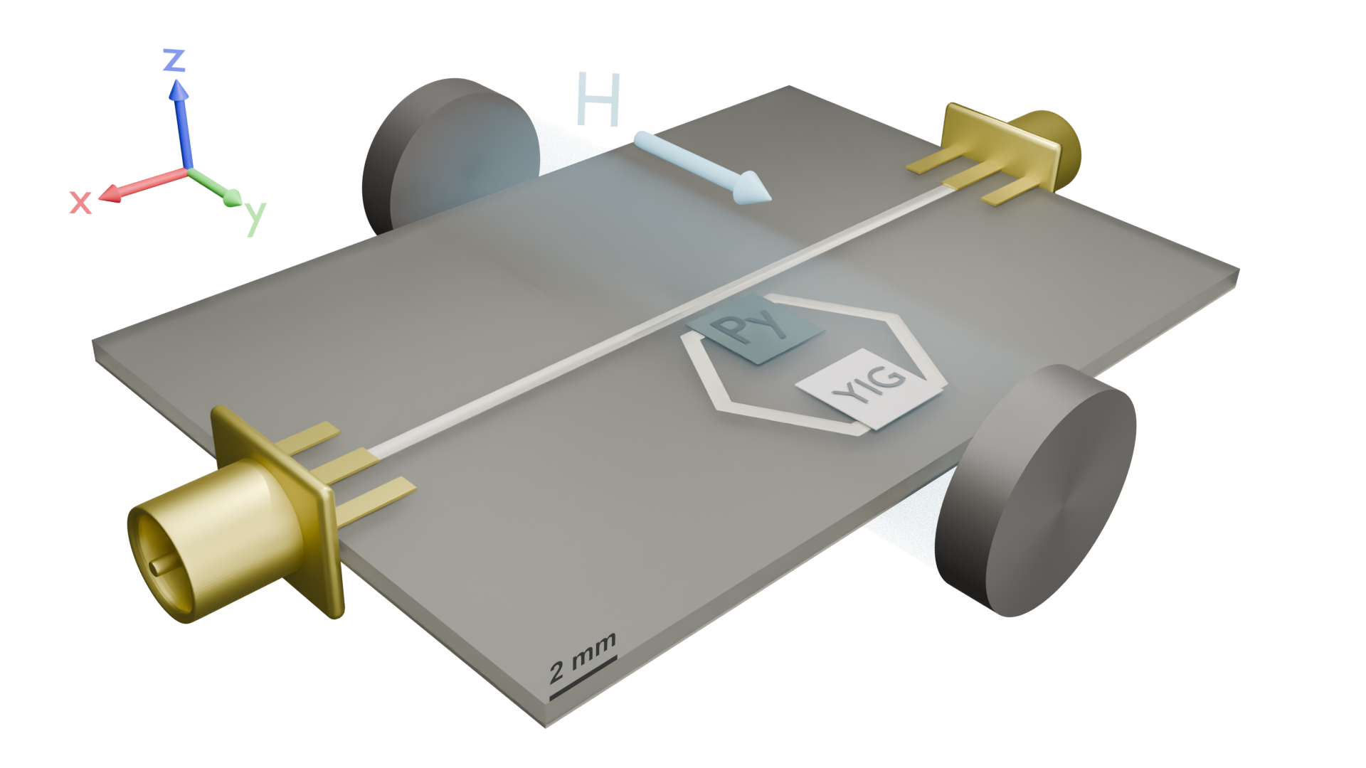

Fig 5: The experimental setup includes the two magnonic films placed at opposing sides of a copper hexagon (the photonic resonator). The ports featured are plugged into a vector network analyzer to both excite the microstrip line and also measure the transmission spectrum while a magnetic field is applied along the *y*-direction pictured here.